**29 Mar 2019** **The Weekly Bulletin of Rotary Club of Kathmandu Mid-Town** **bc-25.3/019**

|  |
| --- |
| C:\Users\Public\Documents\RIP T1819_EN.png |

District: 3292 Web:www.rotarymidtown.org.np Club Id: 26776

**MARCH IS WATER AND SANITATION** **MONTH**

Clean water and sanitation is a human right. When people, especially children, have access to clean water, sanitation, and hygiene, they lead healthier and more successful lives. Rotary clubs doing service projects on water and sanitation must not forget integrating them into education projects. When children learn about disease transmission and practice good hygiene, they do not miss school. And they take those lessons home to their parents and neighbor, expanding Rotary impact.

**Weekly Club Meeting # 1481 held on Friday 15 Mar 2019**

Joint meeting with Rotaract Club of Kathmandu Mid-Town.

Rotary President Jo Logghe called meeting # 1481 to order and handed over the floor to Rtr President.

Rtr President Sushma Shrestha called meeting # 556 to order and presented Rotaract activities during the year 2018-19 to the joint audience Rotarian/Rotaractor. She appreciated the support of the parent club and looked forward for continuing support and more interaction. She also took up the questions/queries of the parent club members.

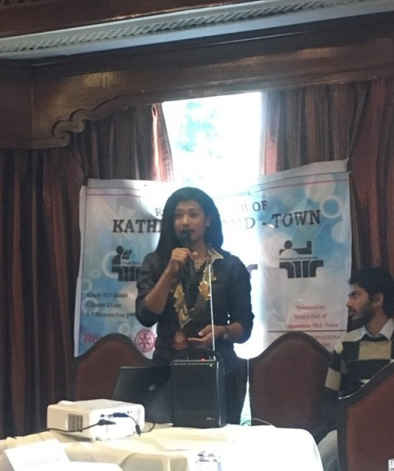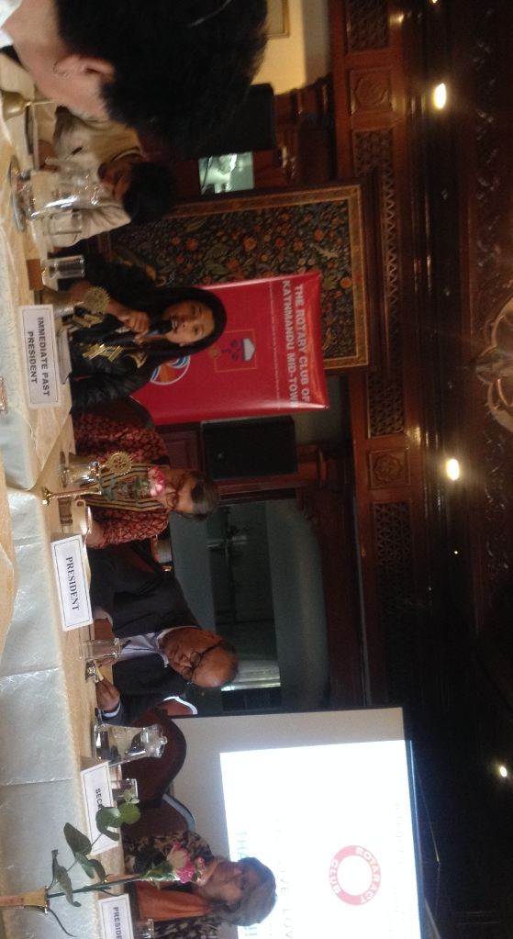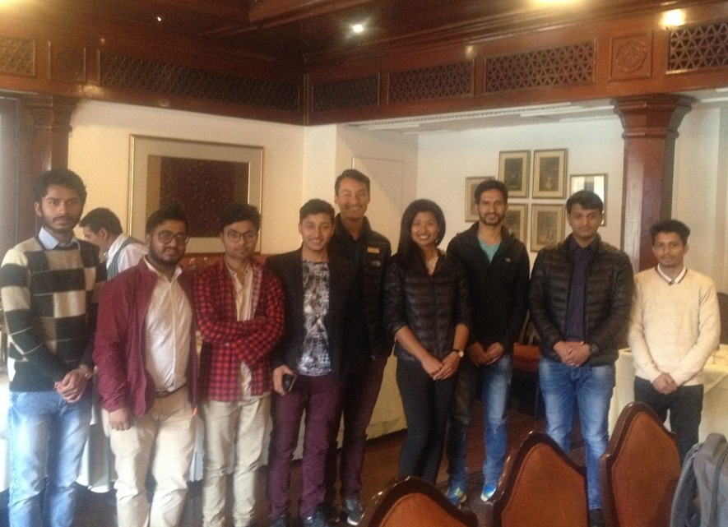

Rtr President Sushma giving presentation, answering the questions from the floor, Rotaracts in a group photo

**Club Meeting # 1482 Friday 22 March**

**Club assembly**

AG Bijaya Mallapaty conducted the Club assembly meeting where chairs of Club Administration, Youth Service, Membership Development, Public Relations, the Rotary Foundation, and Service Projects provided the progress review of activities and programs.

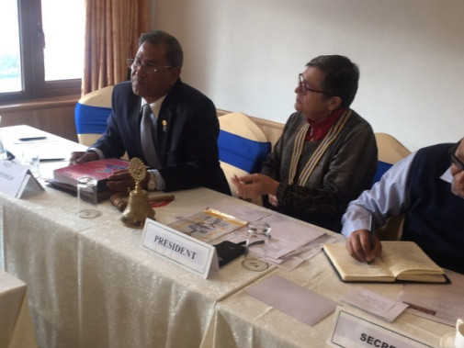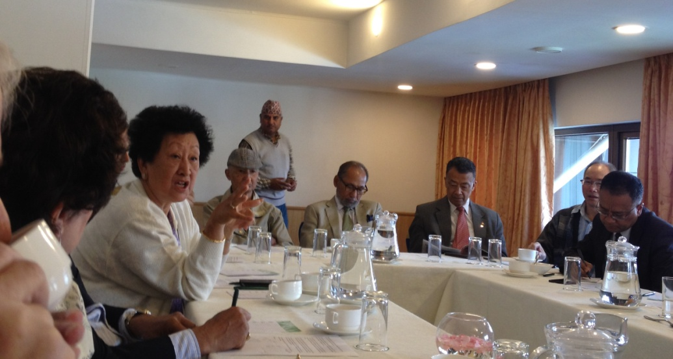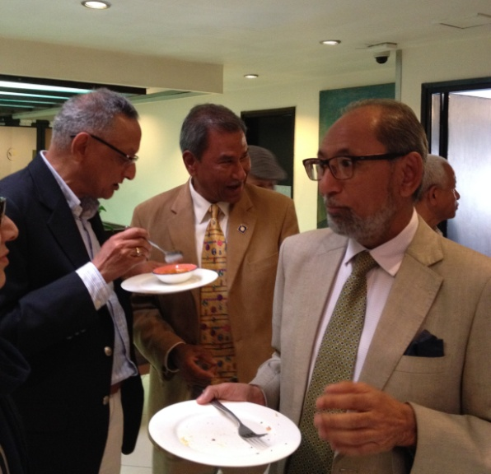

AG Bijaya listening presentations PP Dr Chandra Tuladhar presenting Youth service activities AG Bijaya on fellowships

**Club Meeting # 1483 at Simpani Gairigaon Dhading**

Club meeting # 1483 is scheduled to be held at Simpani, the Simpani Water Project site, on Saturday 30 March 2019. No meeting on Friday 29th March at Hotel Annapurna.

The Simpani Lift Water project, a Global Grant project with partnership and support of RC Masan East, South Korea, has been complete and is in operation. The project will be formally inaugurated and handed over to the local community for day-to-day operation and maintenance.

Since the meeting is scheduled on Saturday, many Mid-Towners hopefully will be able to participate. Besides being a regular weekly meeting this will be a project-site visit as well, and the lunch meeting, community providing lunch.

**Celebration of Rotaract Week: 16 March 2019**

Rotaract Club of Kathmandu Mid-Town celebrated Rotaract week on 16 March by having organized a special program wherein 3 guest speakers were invited to give talks on SDG:

Mr Surendra Panday, UNHCR (retired), Secretary General, Forum of former International Professionals of Multilateral Organizations : What are the SDG? How do they apply in Nepal?”

Ms Marilyn Hoar, UNICEF Nepal, Chief of Education: Why are SDGs important for better education in Nepal

Mr Selwyn Heaton, UN World Food Programme Project Manager, Kathmandu : “Looking to the future – SDGs for development in Nepal”

The program was jointly organised by Rotary/Rotaract/Interact and Jana Sewa Secondary School at Paanga.

There were altogether 60 participants in the program comprising of teachers/students of Jana Sewa Secondary School and Mangal Secondary School, Rotarians, Rotaracts, Interacts and a few local guests.

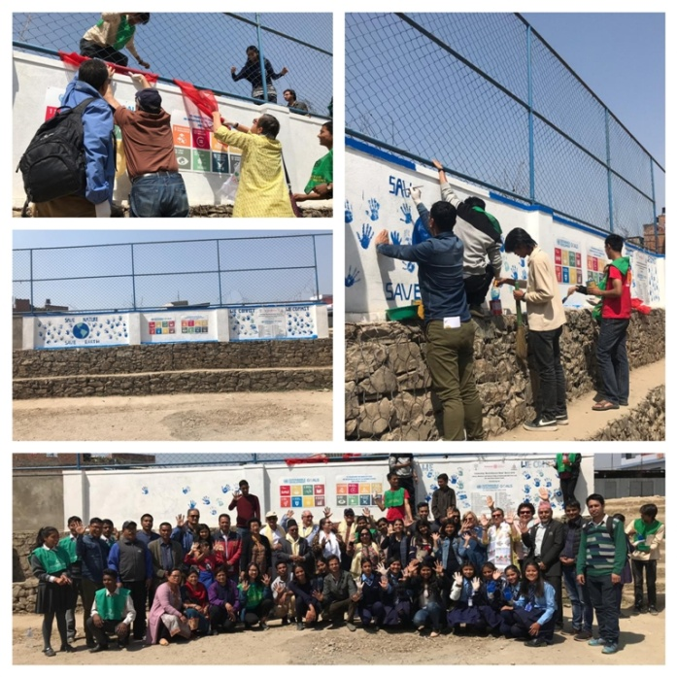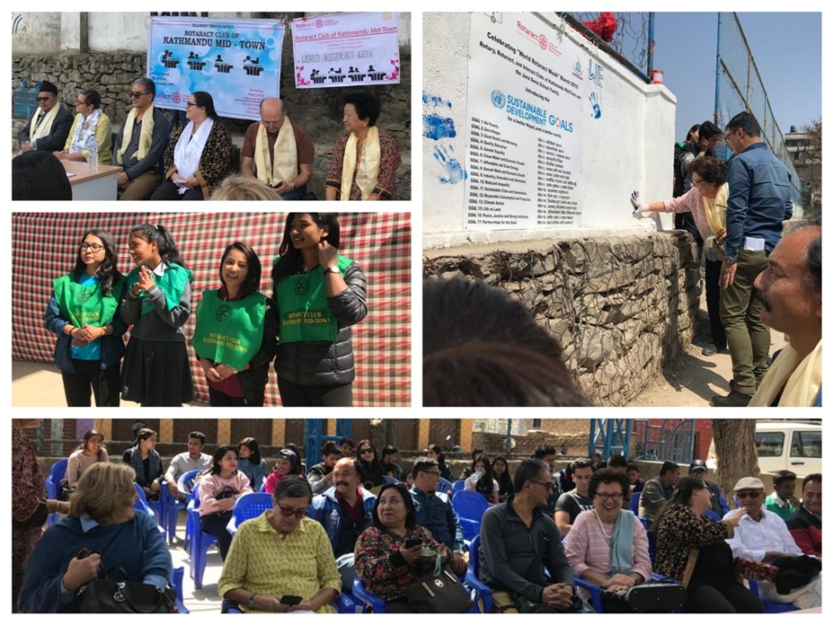

**Do you Know** **?**

The International Space Station, one of the most complex and expensive engineering projects that the human race has ever put together, travels 253 miles (408 km) above the earth at 17,100 (27,519 km/h) miles per hour and completes a full circle of the earth every 90 minutes. Astronauts on board get to see a sunrise and sunset 16 times each day. The [ISS program](https://en.wikipedia.org/wiki/International_Space_Station_program) is a joint project between five participating space agencies: NASA (United States), Roscosmos (Russia), JAXA ([Japan](https://en.wikipedia.org/wiki/Japan)), [ESA](https://en.wikipedia.org/wiki/European_Space_Agency) ([Europe](https://en.wikipedia.org/wiki/Europe)), and [CSA](https://en.wikipedia.org/wiki/Canadian_Space_Agency) ([Canada](https://en.wikipedia.org/wiki/Canada))

*Read more on https://arstechnica.com/sciences*

**A THOUGHT FOR THE DAY**

“Rotary is not an organization to show off our ego or prestige. It is an organization that helps us make friends around the world and serve humanity in a united manner.”

*PRIP Kalyan Banerjee*

On Lighter Side:

A tired traveler pulls into a hotel around midnight. Very tired after a long day's trip he asks the clerk for a single room. As the clerk fills out the paperwork, the man looks around and sees a gorgeous blonde sitting in the lobby.

He tells the clerk to wait while he disappears into the lobby. After a minute he comes back, with the girl on his arm.

"Fancy meeting my wife here," he says to the clerk. "Guess I'll need a double room for the night."

Next morning, he comes to settle his bill, and finds the amount to be over $3,000.

"What's the matter?" he yells at the clerk. "I've only been here one night!"

"Yes," says the clerk, "but your wife has been here for three weeks!"

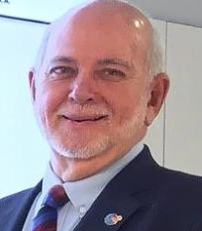

To the Rotaractors: Look for a club that satisfies your needs. If you don’t find one that’s

engaging you, start your own Rotary club. Do it the way you want to do it with your friends

so that you don’t lose the passion for Rotary. Our rules are very flexible today; so it can

happen the way you want it to be.

**RI President Barry Rassin**

Please send information on club activities, progress reviews on service projects, relevant photos etc to:

BC Editor: RR Shrestha email: rryesrr@gmail.com

## 29 Mar 2019 The Weekly Bulletin of Rotary Club of Kathmandu Mid-Town bc-25.3/019

Annex

Rotaract Club of Kathmandu Mid-TownBoard 2019-20

